**E Think**

**1-) Public Pages :**

* Can Users In Public Page Add Contact Form To Contact With Admin.
* Show All Testimonial Which accepted From Admin.
* Connection Information In Footer
* When User Forgot Password … Can Refund Password By Send Code To His Email
* When Trainee Registration He Should Confirm his Email By Send Confirm Code



**2-) Admin Page :**

* Show Analyzing Page (For Users Counts)
* Course List Page CRUD Operations For Courses Table
* Categories List CRUD Operations For Categories Table
* Trainers List CRUD Operations For Trainers
* Accountants List CRUD Operations For Accountants
* Trainees List RUD Operations For Accountants
* Admin Can Block Any User And User Cannot Login
* Contact Us List … List Of Information Which Input From User In Public Page
* Testimonial Page … Testimonial Input From User In Public Page And Admin Determine Any One Will Show In Public Page

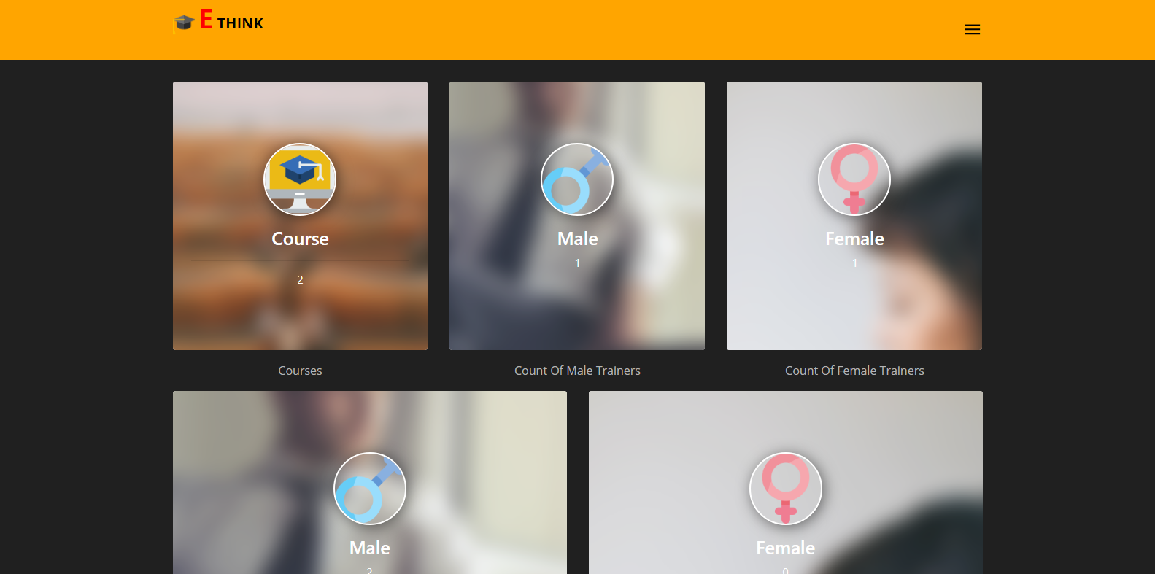

**3-) Trainer Page :**

* Trainer Can Query By Date On Count Of His Courses And Trainees And Other Information (Can Download PDF)
* Courses List Page :

1-) Search Using Interval In His Courses

2-) Details Course (CRUD Operation For Discounts Course), (CRUD Operation For Materials Course), (CRUD Operation For Exams Course), (Information About Trainees In Course)

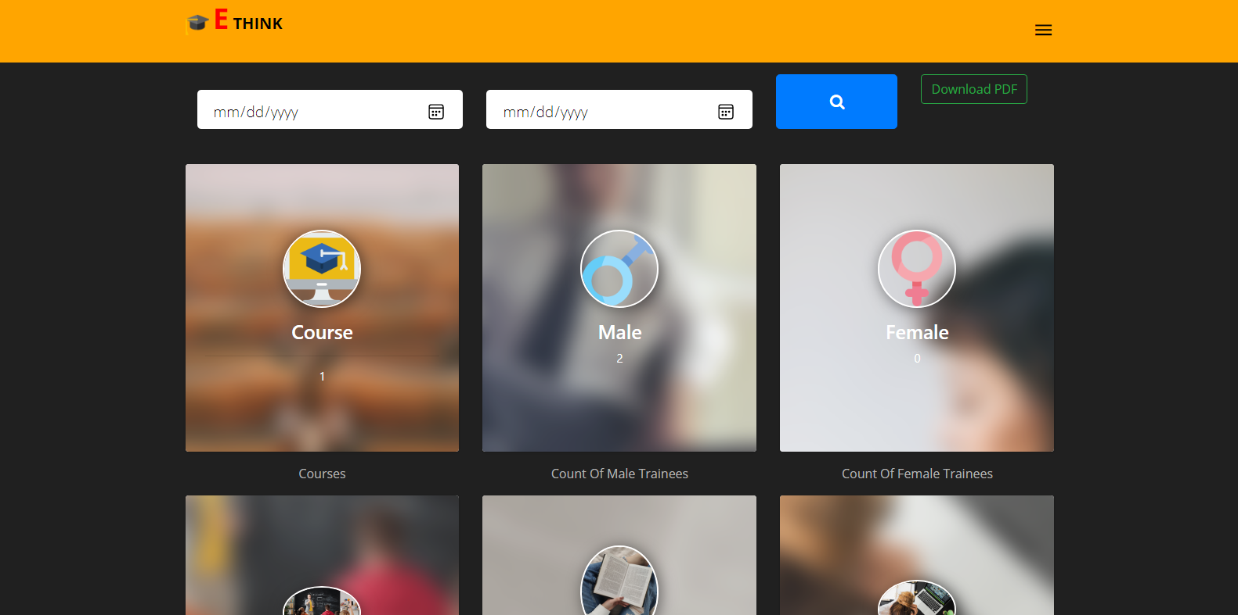

**4-) Trainee Page :**

* Add Testimonial For Public Users.
* Search By Name , Category And Get All Discounts Courses.
* My Courses Page … Show All My Courses.
* Details Course Content (Materials Course),(Exams Course),(Payments Course)
* Card List Page … (CRUD Operations For Card Payments),(When User Change Password Card He Should Confirm Password By His Email)
* My Requests Page Show All Enrolled Courses Which Is Waiting To Accept From Admin

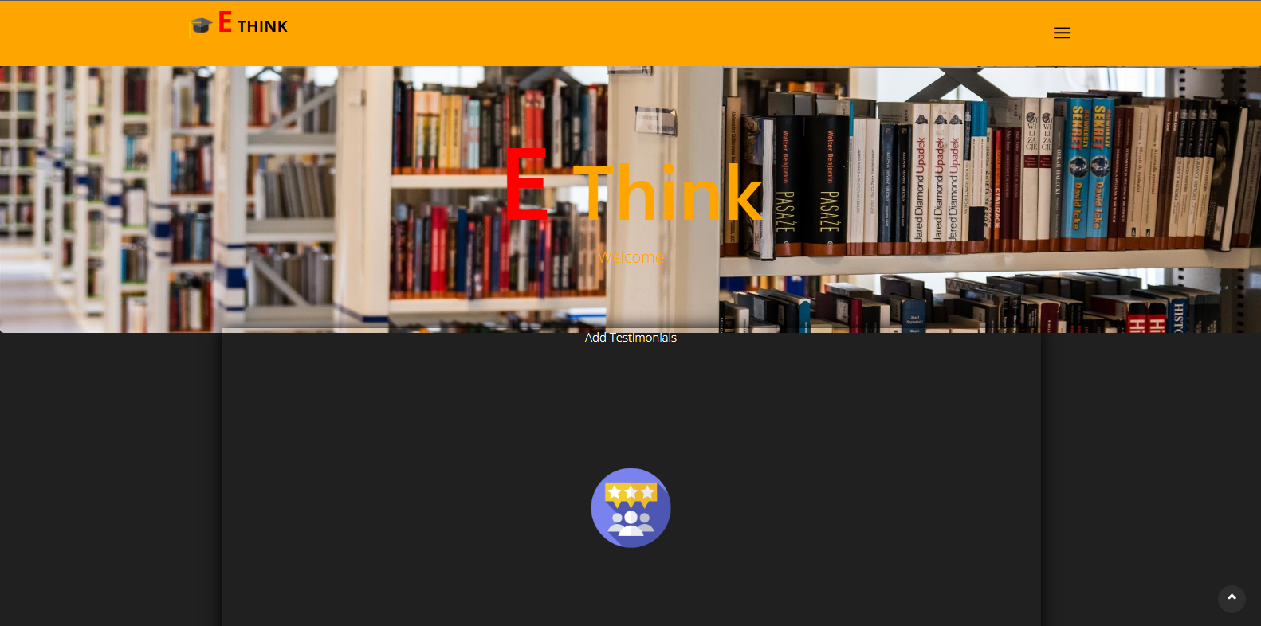

**5-) Accountant Page :**

* Query Using Interval For Financial Report (Can Download PDF File).
* List Pad Payment Page : Show All Payments When Problem Status From Trainee.
* List Trainees : Can Search Use (Username , Email , Category Of Class)
* Details Trainee Can Show Trainee Information And Get Financial Report
* List Employees : Can Search Use (Username , Email ,Role Of User).
* Details Employee Can Show Information And Get Financial Report For His Salary.

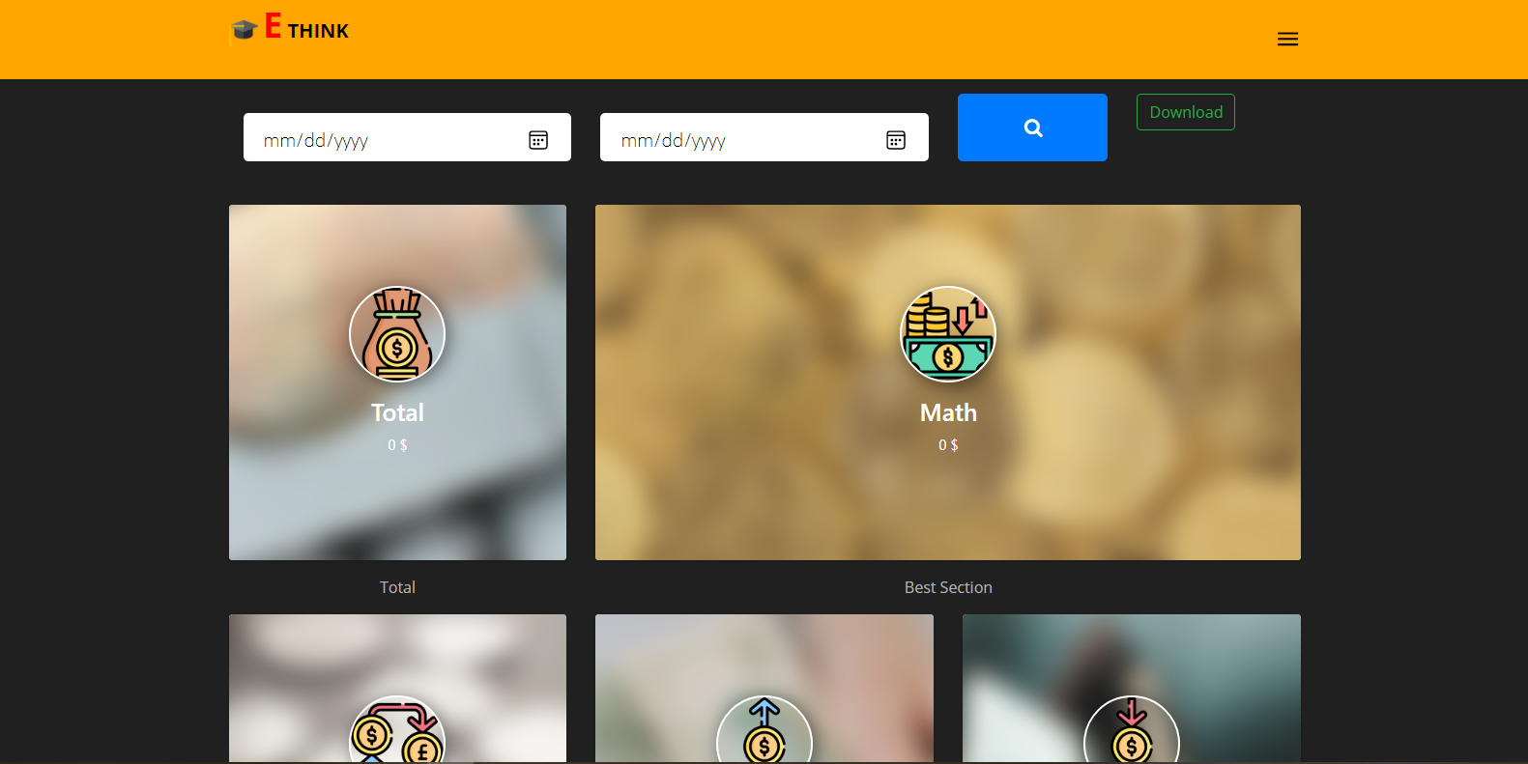

**6-) Shared Page :**

**User Can Edit His Data And Image.**

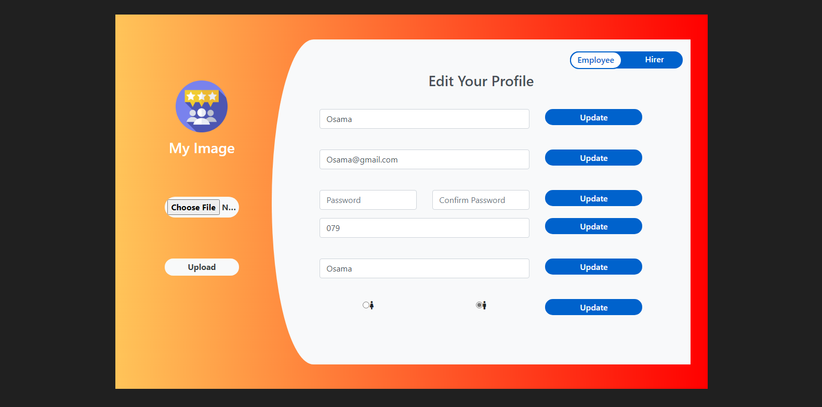

**7-) Authorize :**

**Use RoleProvider In Web.Security Library**